Investment proposal
«Organization of a woodworking enterprise»
Planned production capacity – 20 000 cubic meter of lumber per year

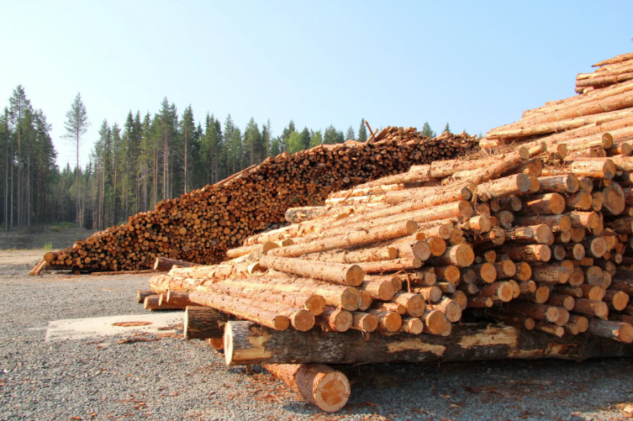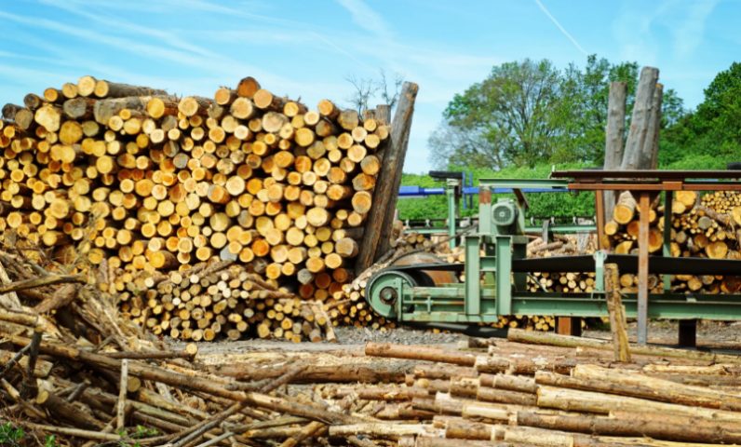
It is planned to open a shop for primary processing(sawing), secondary processing and preservation(drying). The estimated cost of performing these types of work will be 850 thousand US dollars
Payback: 2.5 years
Investor participation in project implementation: project financing
Planned product range for release:
- beam
- rounded log
- board to order
- lumber drying

Feasibility of the project
- Allows you to recoup the invested funds in a fairly short time and get a profit in the future.
- Proximity to the consumer.
- High demand for products on the market.
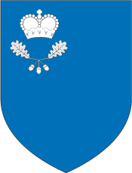

To implement the project, there is:
- Land plot in Malorita with an area of 2.0 hectares
- Railway line at a distance of 300m
- 10KW power line
- Plumbing
- Gas-pipe
- Road at a distance of 500m

- MALORITSKIY DISTRICT EXECUTIVE COMMITTEE
- ADDRESS: Brest region, Malorita, Krasnoarmejskaja str., 1
- E-mail:
mal_econ1@brest-region.gov.

- TEL:
80165120040 80165120038 80165120053–
fax

The main consumers
- Domestic market
Republic of Belarus
- European Union market
- CIS market

